Hey Krishna/ Future Co-op

Here is a guide and reference to all the important files and work I have done over the term.

I have created a folder that consists of eight subfolders and it looks like this

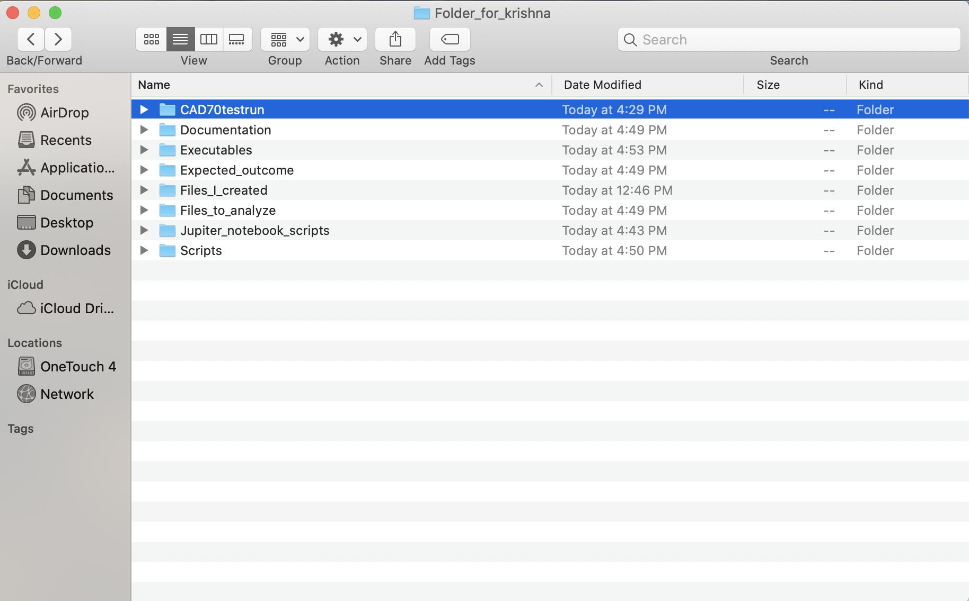

* **CAD70testrun -**  this is folder that contains all the things that were necessary to run a CAD70 analysis and also contains the results.
* **Documentation-** consists of all the documents that are important for any information related to scripts and files in this directory
* **Executables –** consist of some python executables that I have tried out
* **Expected_outcome –** consists of all the expected results needed for certain scripts I have organized it in a way so you can see what script can product the files in it
* **Files_I_created –** consists of any files I manually analyzed/ created without scripts
* **Files_to_analyze –** consists of any input files needed for all the scripts, we will go over everything in detail in this following document
* **Jupiter_notebook_scripts –** this is all my preliminary Jupiter notebook scripts. They aren’t useful in terms of the project now but are there for reference.
* **Scripts -**  you guessed it! It is where all the scripts are! We will go over details of that as well

Now let’s understand each subfolder properly!

**CAD70testrun**

Let’s look at the **CAD70.xlsx** file. You are now basically bioinformation. You will be helping us solve how likely it is for a human to get cardiovascular disease based on certain factors of course. Let’s look at the file below.

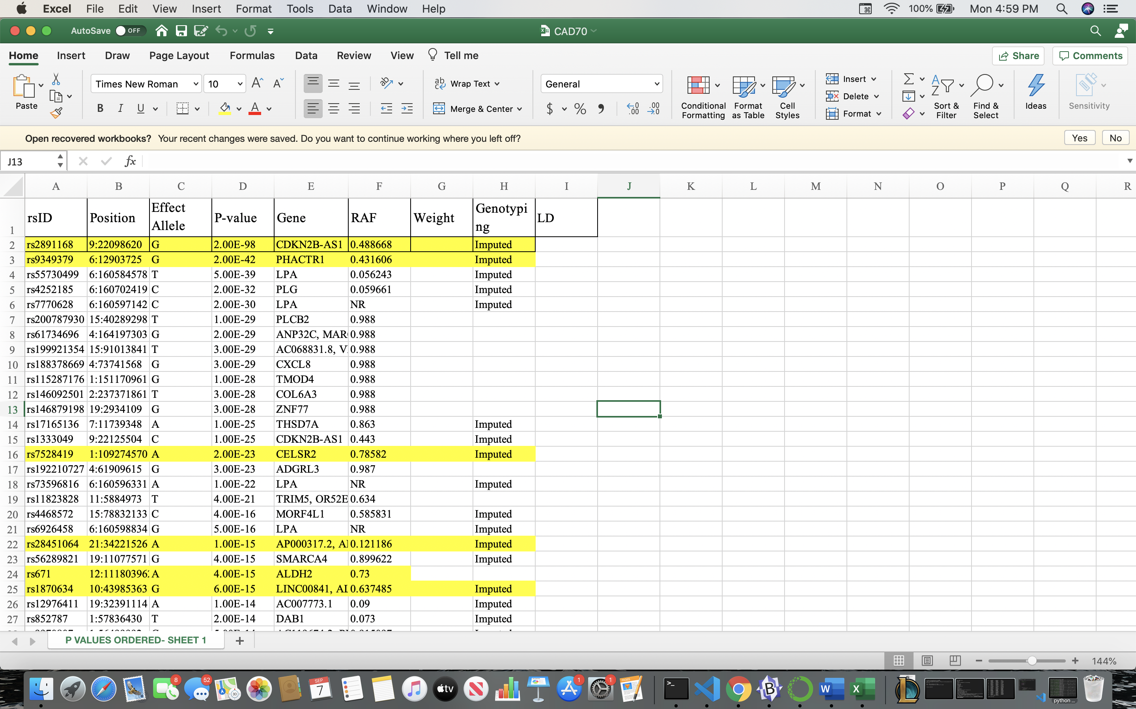

This file consists of the 70 unweighted SNPS (single nucleotide polymorphisms) that are present in an Asian human population. The first row has the rsid which is the unique id number that identifies the SNP. The next is the position number which tells you the chromosome the SNP is present in and the exact nucleotide position it is at. For example, **9:22098620** the number 9 represents the chromosome number, the 22098620 is the exact nucleotide position number that the SNP is in. The next column is the effect allele which is the exact nucleotide that will cause the heart disease effect depending on where it is on the DNA strand. **Remember DNA is double stranded so there is a forward (reference strand) and a backwards (alternate strand).** The next thing to focus is the weight column. This worksheet does not contain the weights, but Jian and Gilda have been working on calculating the weights. The weights are important as they help calculate the degree of the cardiovascular risk based on where the effect allele is. This degree is super important as it helps us with predict how likely it truly is for that specific patient to have cardiovascular disease.

**CAD70script.py**  - this is the script that runs all the analysis on the human sample and the cad70.xlsx file. There is detailed comments in this script. Let me know if something doesn’t make sense. It is important to download pandas, numpy, scikit-allel prior to running the script. **\*\*DISCLAIMER** This script drains a lot of battery and takes around 1 ½ hours to run per VCF sample\*\***

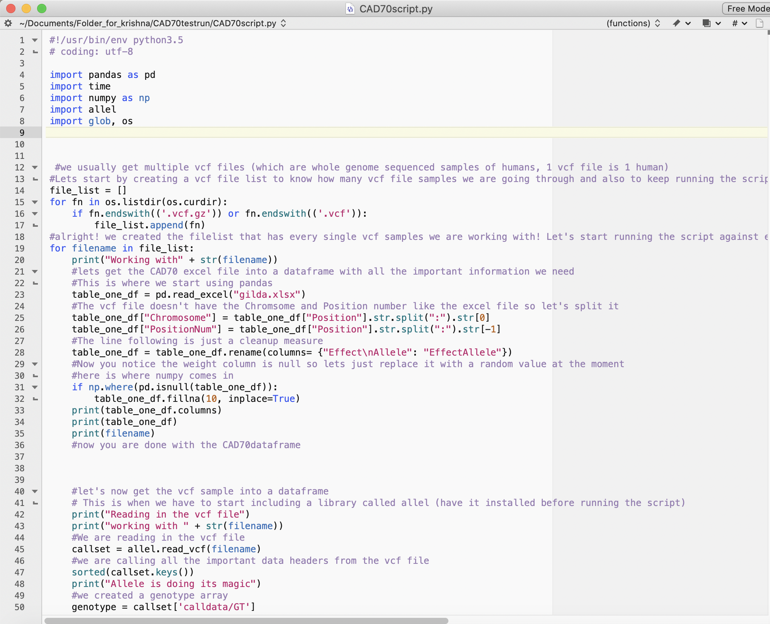

**Percentile.xlsx**

This file consists of the percentile we look at to analysis based on the weighted score calculated for that human. The chart looks as follows and is very self-explanatory. \*\***DISCLAIMER we are currently using the same percentile chart for CAD70 as CAD267\*\***

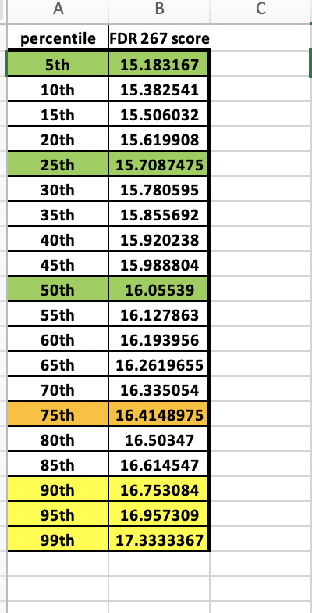

**Now here are the output files**

**220d9976-ebed-4ea1-8c09-46723ddac703_BGI.xlsx -** consists of the output information we will give to our BGI collaborators. The file look like the picture below

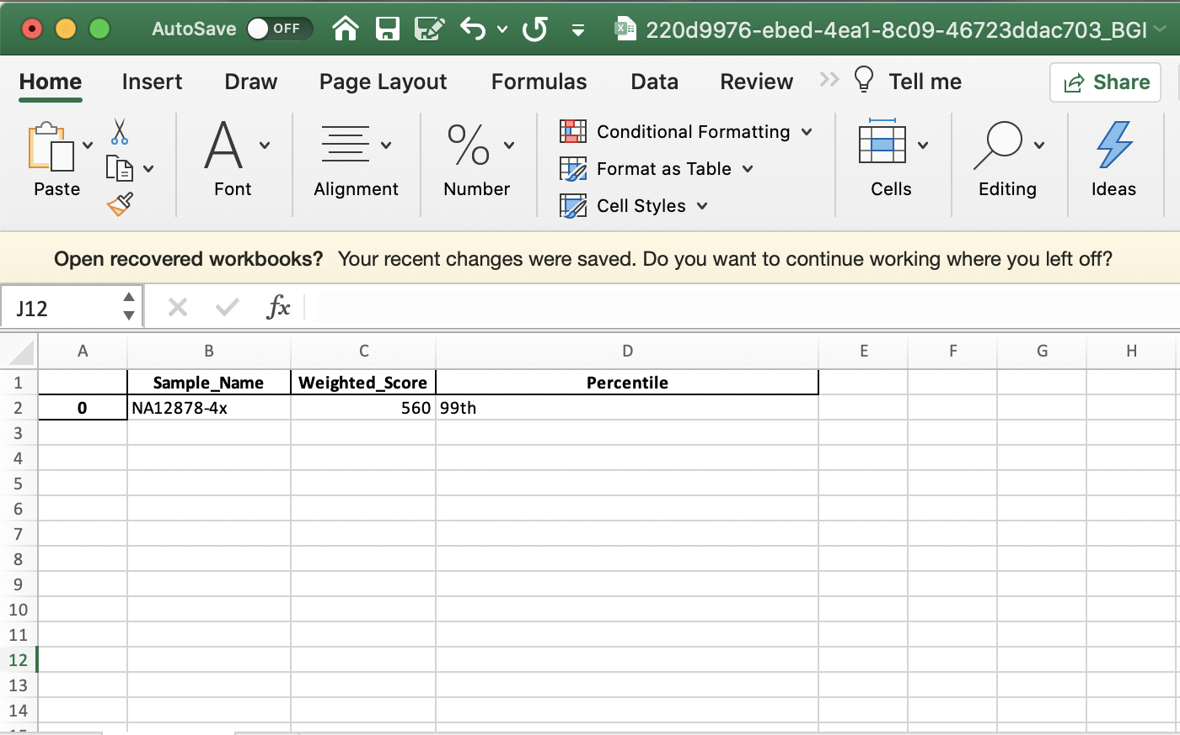

**220d9976-ebed-4ea1-8c09-46723ddac703_Hegele.xlsx –** contains all the information needed for our lab. It looks like the picture below. (it has the merged dataframe)

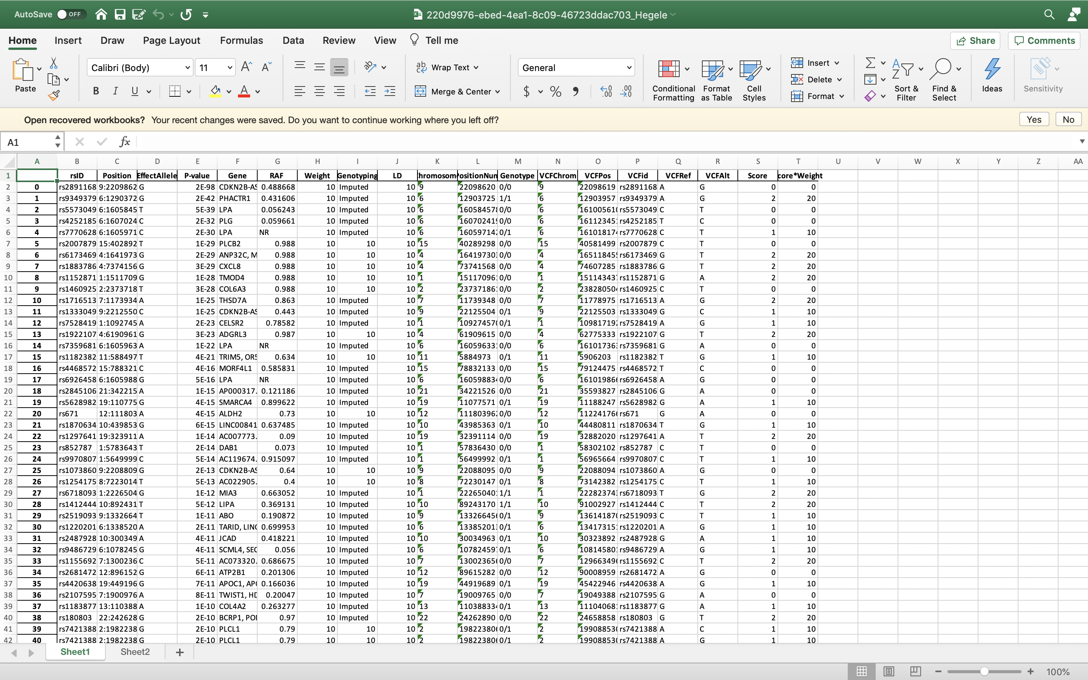

**220d9976-ebed-4ea1-8c09-46723ddac703.vcf.gz -** is the vcf sample that we have been using for our testing. (don’t open it because it is too big, and your laptop will crash)

**Alright done with folder 1 lets go to the next folder!**

**Documentation**

You guessed it! This is the folder that will include all the important documentation for the scripts and the files (including this one)

There are 4 files currently (I still have to move this document into that folder) but everything is very self-explanatory

I will also create an installation guide for all the libraries we are using and will also include the useful links email I sent you. (In progress right now)

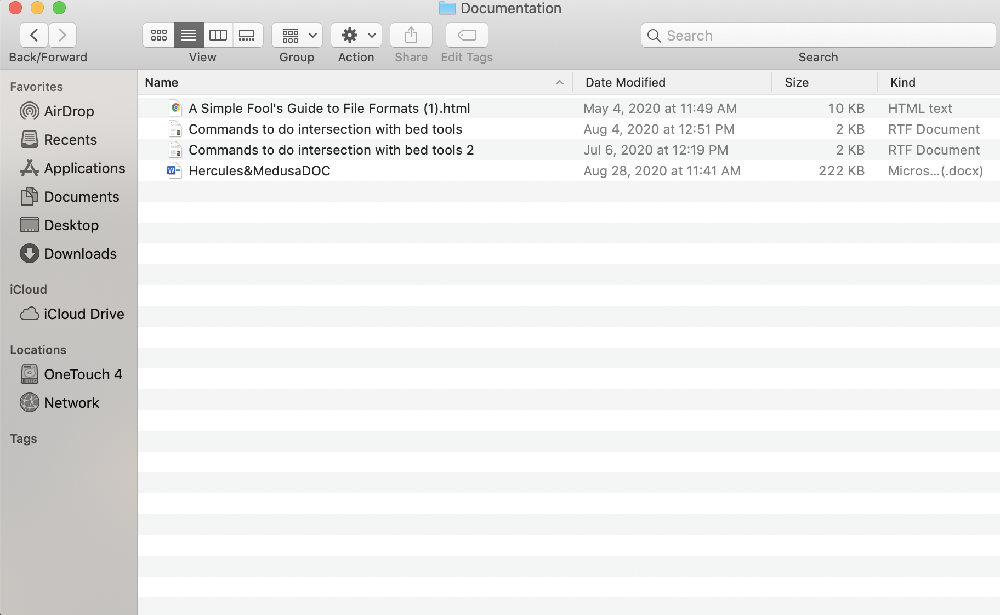

**Executables**

This is where you will find an executable called finalbed there is a unix one and a python one. Since you have a mac run the unix one and that will run the toolbox for **JUST THE BED FILE ANALYSIS.**  There will be a folder that has all the files required for you to run the toolbox and conduct the bed file analysis. You should see something like this

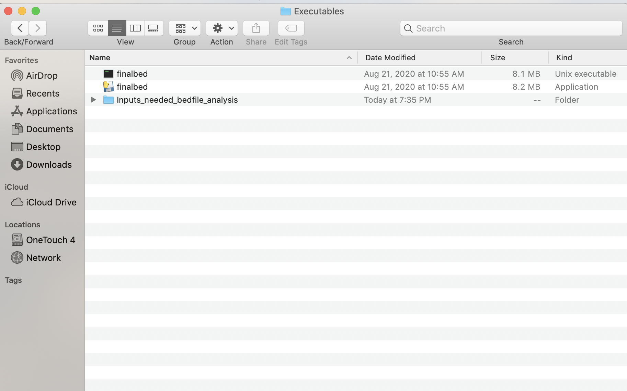

Click on that input_needed folder to set it as your working directory. Let me show you what happens when you click on the finalbed unix executable

You should see something like this:

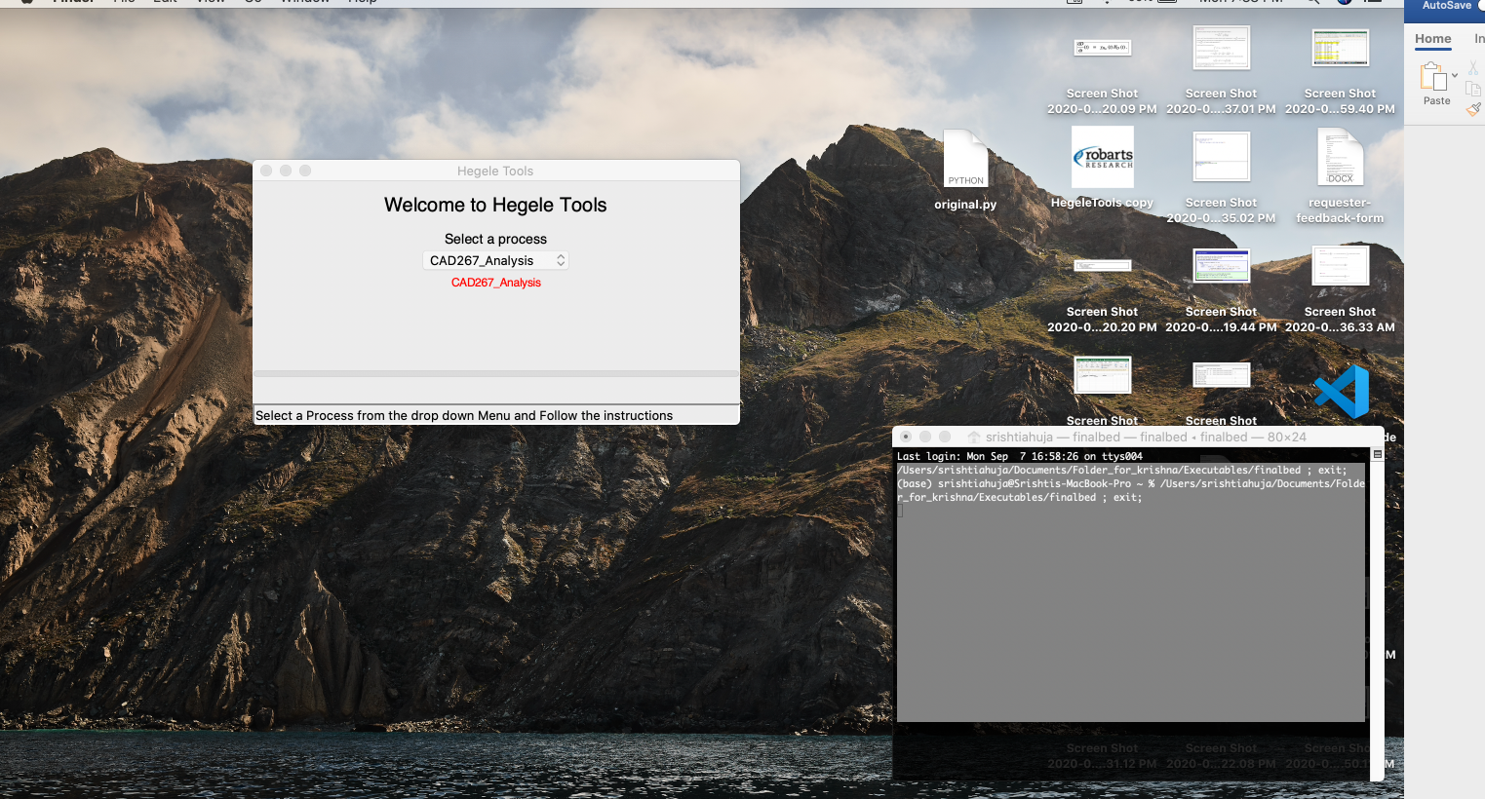

Now you see this is the toolbox that popped up select bed file analysis as the process

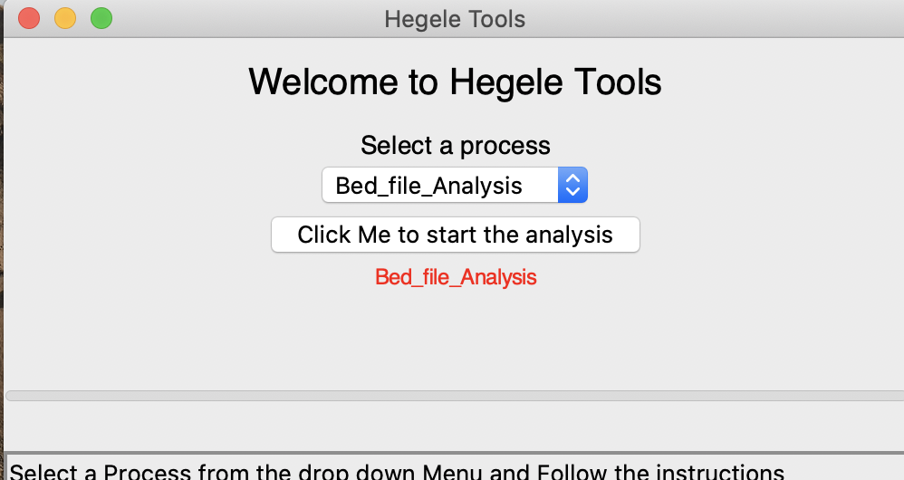

Once you do you will press the click me button

You should get a prompt that looks like this:

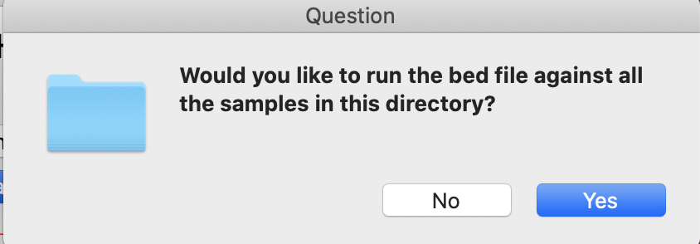

Click on yes for now

After that you should get another prompt

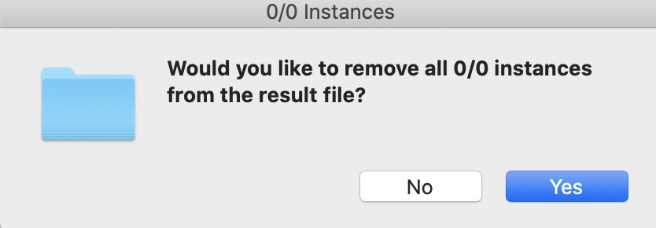

Click on yes for now

The toolbox will then prompt you to select your working directory (like I mentioned above it is where the input files are)

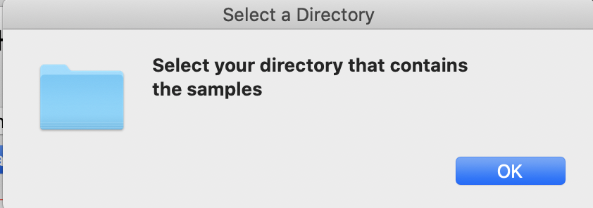

So you should select this directory under executables

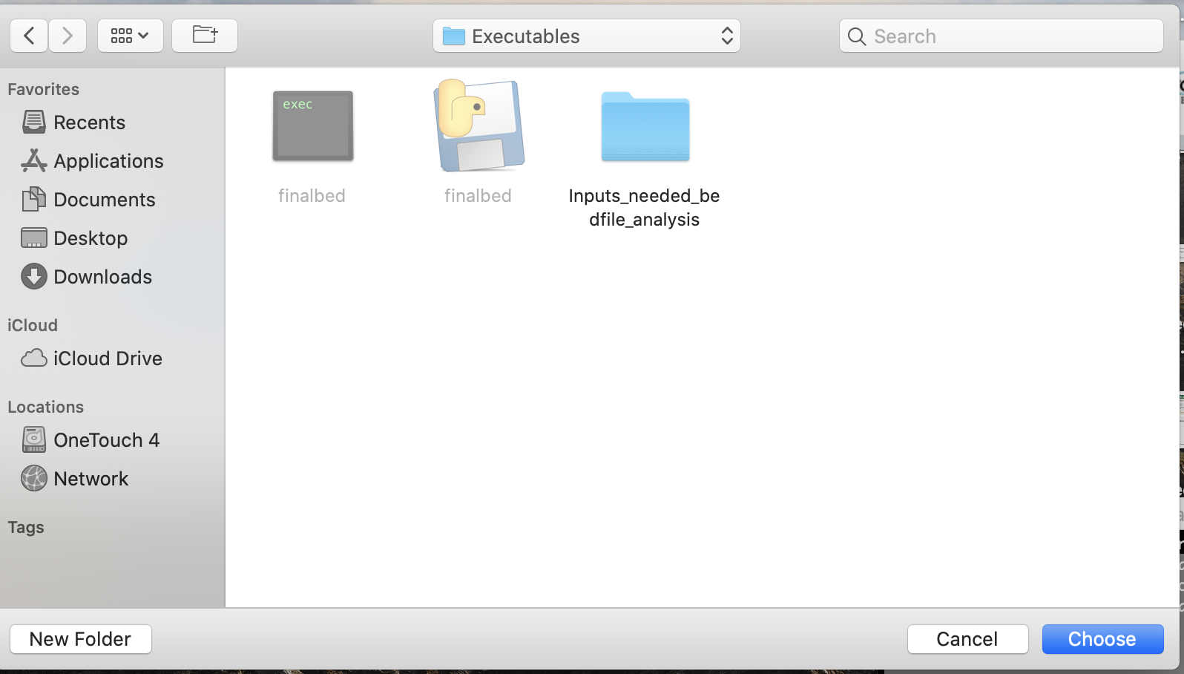

Click on choose

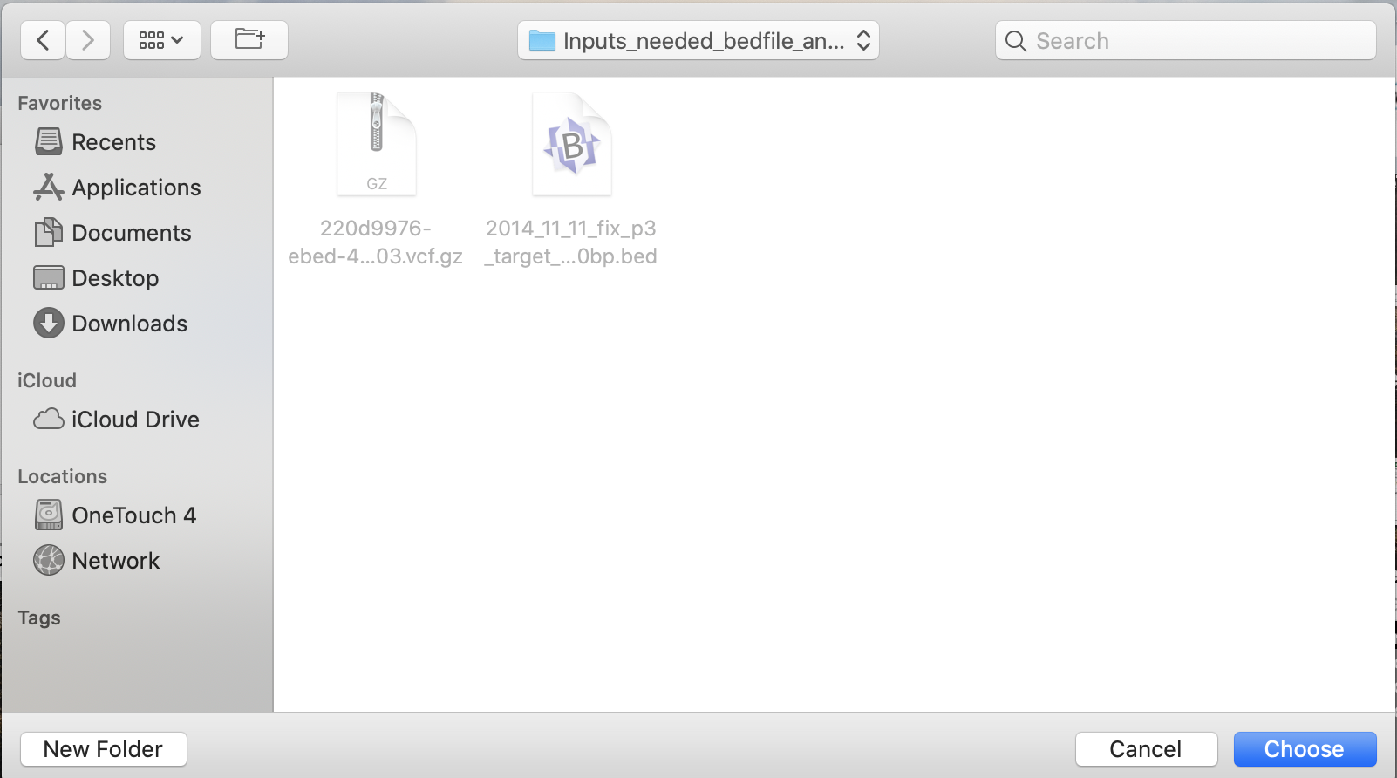

It will then prompt you to select a .bed file

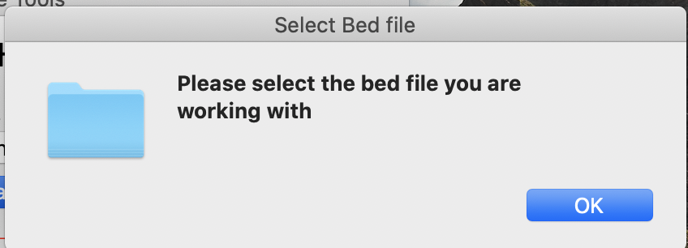

Click ok

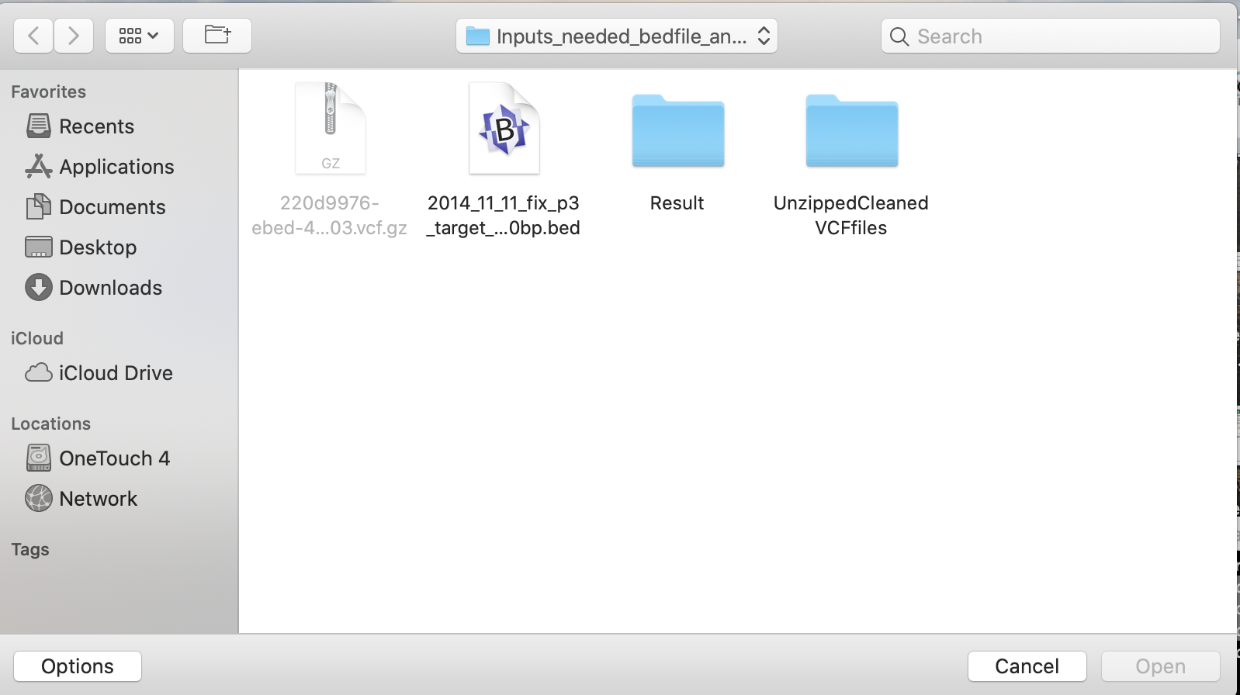

Click on that .bed file

And the process should start.

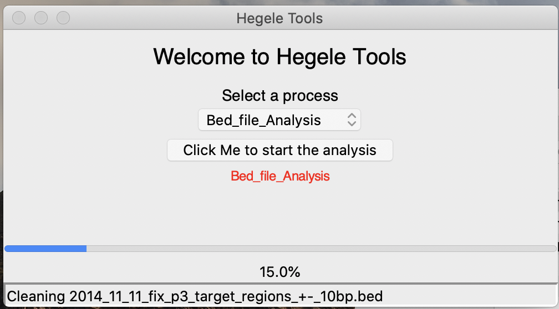

This is fully functioning and should create sub folders in your working directory and have the results in around 10 mins

Expected results (what it looks like in the folder) after the run

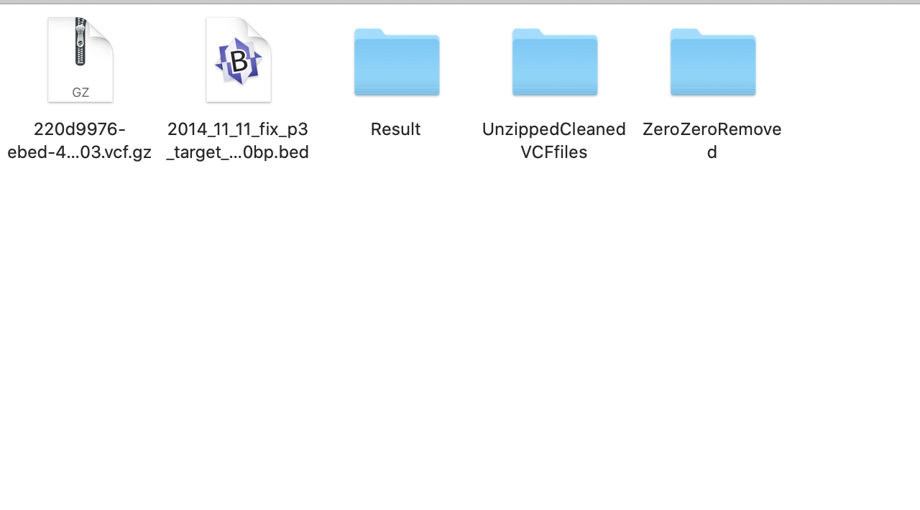

You will see the files present in those subfolders after the analysis is done